Project Design Phase-II
Data Flow Diagram & User Stories
Field | Details
Date | 04 November 2025
Team ID | NM2025TMID06302
Project Name | Medical Inventory Management System
Maximum Marks | 4 Marks

Data Flow Diagrams:
A Data Flow Diagram (DFD) is a traditional visual representation of the information flows within a system. A neat and clear DFD can depict the right amount of the system requirement graphically. It shows how data enters and leaves the system, what changes the information, and where data is stored.
In the project "Medical Inventory Management System", Data Flow Diagrams (DFDs) illustrate how inventory transactions, purchase orders, and expiry monitoring are processed within the system. The DFD shows the interaction between the pharmacist, inventory manager, purchase manager, the Salesforce system, and the database to validate stock levels, monitor expiry dates, and track supplier deliveries. If a product's stock falls below minimum levels or expiry approaches, the system triggers automated alerts to maintain patient safety and operational efficiency.
Example:
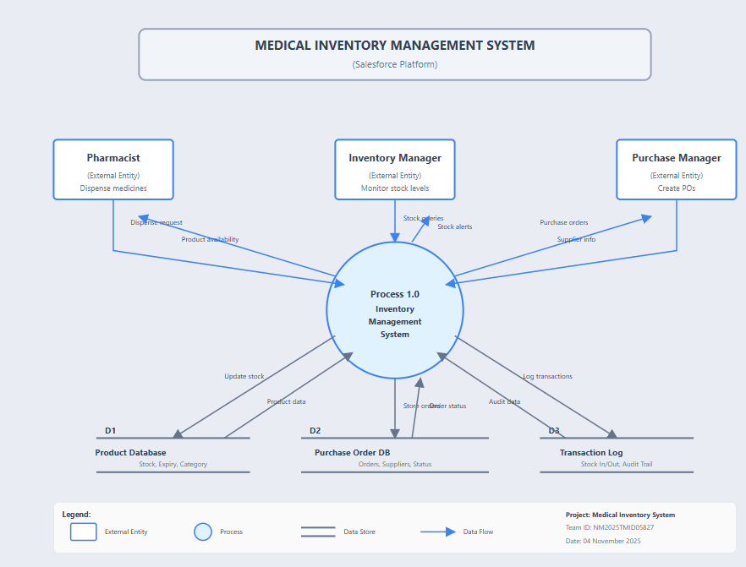
Data Flow Diagram - Level 1 (Detailed Process)
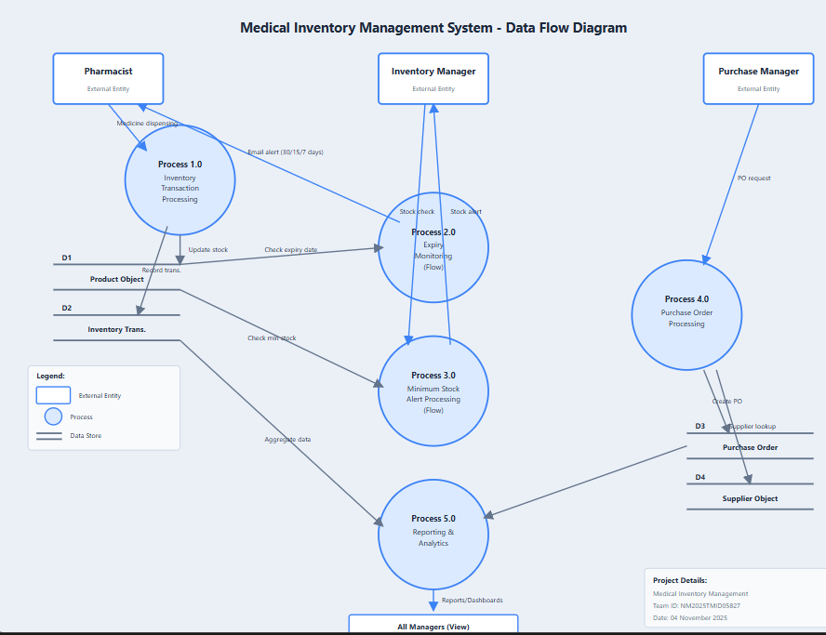
Data Flow Details:
- Pharmacist initiates medicine dispensing → System validates stock availability
- System records Inventory Transaction (Stock Out) → Updates Product.Current_Stock
- Flow monitors Expiry_Date daily → Sends alerts at 30, 15, 7 days
- Flow monitors Current_Stock → If below minimum, alerts Inventory Manager
- Inventory Manager reviews alerts → Creates Purchase Order
- Purchase Manager selects Supplier → Adds Order Items
- Trigger calculates PO Total Amount automatically
- Validation Rule ensures Expected_Delivery > Order_Date
- When PO Status = "Delivered" → Flow updates Actual_Delivery_Date
- Stock arrives → Inventory Transaction (Stock In) → Updates Current_Stock
- Reports aggregate data → Dashboards visualize metrics
User Stories:
User stories define what different users need from the system in simple, goal-focused language. In this project, they help ensure the system prevents expired medicine dispensing, maintains optimal stock levels, and enables efficient purchase order management.
User Type | Functional Requirement (Epic) | User Story Number | User Story / Task | Acceptance Criteria | Priority | Release
Pharmacist | Expiry Monitoring | MIS-US-1 | As a pharmacist, I want to receive automated alerts 30 days before product expiry. | System sends email alert when Expiry_Date - TODAY() = 30 days. Alert includes Product Name, Current Stock, Expiry Date. | High | Sprint-8
Pharmacist | Expiry Monitoring | MIS-US-2 | As a pharmacist, I want to receive alerts 15 and 7 days before product expiry. | System sends escalating alerts at 15 and 7 days. Alert includes urgency level and recommended action. | High | Sprint-8
Pharmacist | Inventory Search | MIS-US-3 | As a pharmacist, I want to quickly search for products by name to check stock and expiry. | Search returns results within 2 seconds. Displays Current Stock, Expiry Date, Location. | High | Sprint-3
Inventory Manager | Stock Monitoring | MIS-US-4 | As an inventory manager, I want alerts when stock falls below minimum levels. | System sends email when Current_Stock < Min_Stock_Level. Alert includes reorder quantity recommendation. | High | Sprint-9
Inventory Manager | Transaction Tracking | MIS-US-5 | As an inventory manager, I want to record stock movements (Stock In/Out) with complete audit trail. | System captures Product, Type (In/Out), Quantity, Date, Performed By. Transaction updates Current_Stock automatically. | High | Sprint-2
Inventory Manager | Dashboard View | MIS-US-6 | As an inventory manager, I want a dashboard showing current stock levels, expiry alerts, and low stock warnings. | Dashboard displays real-time metrics with color-coded alerts (Red: Critical, Yellow: Warning, Green: OK). Refreshes every 5 minutes. | Medium | Sprint-11
Purchase Manager | Supplier Management | MIS-US-7 | As a purchase manager, I want to maintain supplier contact information (Name, Phone, Email, Address). | System stores supplier details. Allows search and filter by name. Displays all active purchase orders per supplier. | High | Sprint-2
Purchase Manager | Purchase Order Creation | MIS-US-8 | As a purchase manager, I want to create purchase orders linked to suppliers. | PO creation form includes Supplier lookup, Order Date, Expected Delivery Date, Status picklist. | High | Sprint-1
Purchase Manager | Order Item Management | MIS-US-9 | As a purchase manager, I want to add multiple products to a purchase order with quantities and prices. | System allows adding Order Items. Each item has Product lookup, Quantity, Unit Price. Trigger auto-calculates Line Total and PO Total. | High | Sprint-9
Purchase Manager | Supplier Performance | MIS-US-10 | As a purchase manager, I want reports showing supplier on-time delivery rates and total spending. | Report groups POs by Supplier. Shows Total Orders, Total Amount, On-Time %, Average Delay. Sortable and filterable. | Medium | Sprint-10
System (Auto) | Data Validation | MIS-US-11 | As a system, I must prevent users from entering Expected Delivery Date before Order Date. | Validation Rule displays error: "Expected Delivery Date must be after Order Date" if rule violated. User cannot save record. | High | Sprint-6
System (Auto) | Automatic Calculation | MIS-US-12 | As a system, I must automatically calculate Purchase Order total when items are added/updated/deleted. | Trigger fires on Order Item insert/update/delete. Calculates Total = Sum(Quantity × Unit Price). Updates PO.Total_Amount field. | High | Sprint-9
System (Auto) | Delivery Date Update | MIS-US-13 | As a system, I want to auto-populate Actual Delivery Date when PO Status changes to "Delivered". | Flow triggers when Status = "Delivered". Sets Actual_Delivery_Date = TODAY(). Calculates delivery time variance. | Medium | Sprint-9
Administrator | Object Setup | MIS-US-14 | As an admin, I want to create custom objects (Product, Purchase Order, Supplier, Inventory Transaction). | Objects created with proper naming conventions. Relationships established (Lookups, Master-Detail). | High | Sprint-1
Administrator | Security Configuration | MIS-US-15 | As an admin, I want to create profiles (Inventory Manager, Purchase Manager) with appropriate CRUD permissions. | Inventory Manager: Full access to Product, Inventory Transaction. Read-only to PO, Supplier. Purchase Manager: Full access to PO, Supplier. Read/Edit to Product. | High | Sprint-6
Administrator | User Management | MIS-US-16 | As an admin, I want to create users and assign them to appropriate profiles and roles. | User creation includes Profile assignment, Role assignment, Email, License type. User can log in and access permitted objects. | Medium | Sprint-7
Auditor | Audit Trail | MIS-US-17 | As an auditor, I want to see complete history of all inventory transactions with user information. | Inventory Transaction object tracks: Who (User), What (Product), When (Date/Time), Type (In/Out), Quantity. Records are immutable. | Medium | Sprint-10
Auditor | Compliance Reporting | MIS-US-18 | As an auditor, I want detailed reports showing all purchase orders with line items for compliance review. | Report includes: PO Number, Supplier, Order Date, Delivery Dates, Product Details, Quantities, Amounts, Status. Exportable to Excel. | Medium | Sprint-10
Healthcare Administrator | Cost Analytics | MIS-US-19 | As an administrator, I want dashboards showing monthly spending trends and budget utilization. | Dashboard displays: Monthly Spending (bar chart), Budget vs Actual (gauge), Top 10 Products by Cost (pie chart), Spending by Category (donut chart). | Low | Sprint-11
Tester | Flow Testing | MIS-US-20 | As a tester, I should verify expiry alerts are sent at correct intervals (30, 15, 7 days before expiry). | Test creates products with expiry dates. Verifies email alerts received at correct times. Alert content accurate. | High | Sprint-11
Tester | Trigger Testing | MIS-US-21 | As a tester, I should verify Purchase Order total calculates correctly for bulk operations. | Test creates PO with 50+ items. Verifies total = sum of all line items. Tests insert, update, delete scenarios. Performance under 3 seconds. | High | Sprint-12
Developer | Documentation | MIS-US-22 | As a developer, I want to document all automation (Flows, Triggers) with comments and design specs. | Each Flow has description, version, last modified. Triggers include code comments. Architecture diagrams created. | Medium | Sprint-12

